On the Combined spreadsheet in the np3model.xlsx Excel Workbook, we need data from both years 2017 and 2016 in order to make year-to-year comparisons.
We therefore need a way to pull data for specific years from the BalanceSheet spreadsheet and from the IncomesStatement spreadsheet.

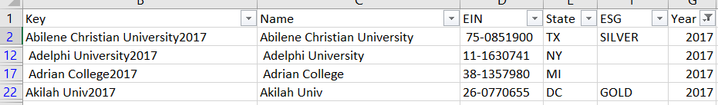

Since VLOOKUP can only use one column for matching, we need to get everything we need in a single column. This was done in Combined by adding a column to the left of the sheet and populating it with a concatenation of Name and Year.

In order to match, that same Key needs to be placed on both the BalanceSheet as shown below.
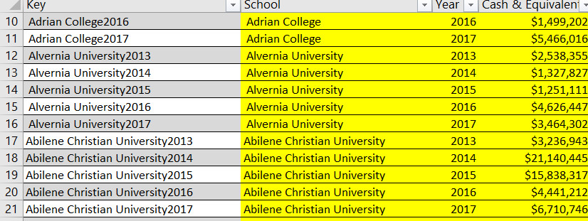

This allows us to retrieve data for a specific institution and a specific year from the BalanceSheet spreadsheet. First, the data in the BalanceSheet is selected and defined to be in a Table named Balance. This table name can then be used to select data without going through the effort of specifying a range.
Let’s assume that we want to retrieve some balance sheet data for Abilene Christian University and place it on Row 2 in the Combined sheet. (See the first figure above). By using the Key in Column B on the Combined sheet, data from Row 21 on the BalanceSheet (second figure above).
VLOOKUP (B2, Balance,4, FALSE) would retrieve $6,710,746 from the BalanceSheet.
Now let’s assume we want to retrieve 2016 data from BalanceSheet and place it on the 2017 Row for Abilene Christian University. The key we need to use in the name of the institution (column C on the Combined sheet followed by the year 2016). We can create this key by concatenating these two pieces of information together (CONCAT(C2,2016)).
The statement to retrieve the data for year 2016 is
VLOOKUP (CONCAT(c2,2016), Balance,4, FALSE). This statement will retrieve $4,441,212 from row 20 in the BalanceSheet.
Using these two statements in Row 2 of the sheet Combined allows us to get data from both year 2017 and year 2016 into the same row on the sheet Combined.
The easiest way to limit sheet Combined to only rows for year 2016 is to setup a filter on the Year column (Column G) in the first figure. If you were to save sheet Combined as a csv file, the filtered-out rows would appear in the csv file. To avoid that, copy the filtered Combined sheet to a new sheet. In the spreadsheet being used in this unit, the name of that new sheet is Combined2017. The sheet Combined2017 can then be used to save a csv file that can be input to other analysis programs such as “R” or Tableau.

